**Unit 7 SQL Queries**

Corey Crooks

Purdue University Global

IT163 – Kathi Nicholson

April 14, 2021

1. **Select the Company field from the Customers table.**

SELECT Company

FROM tblCustomers;



1. **Modify QueryA to sort the output in alphabetical order.**

SELECT Company

FROM tblCustomers

ORDER BY Company;

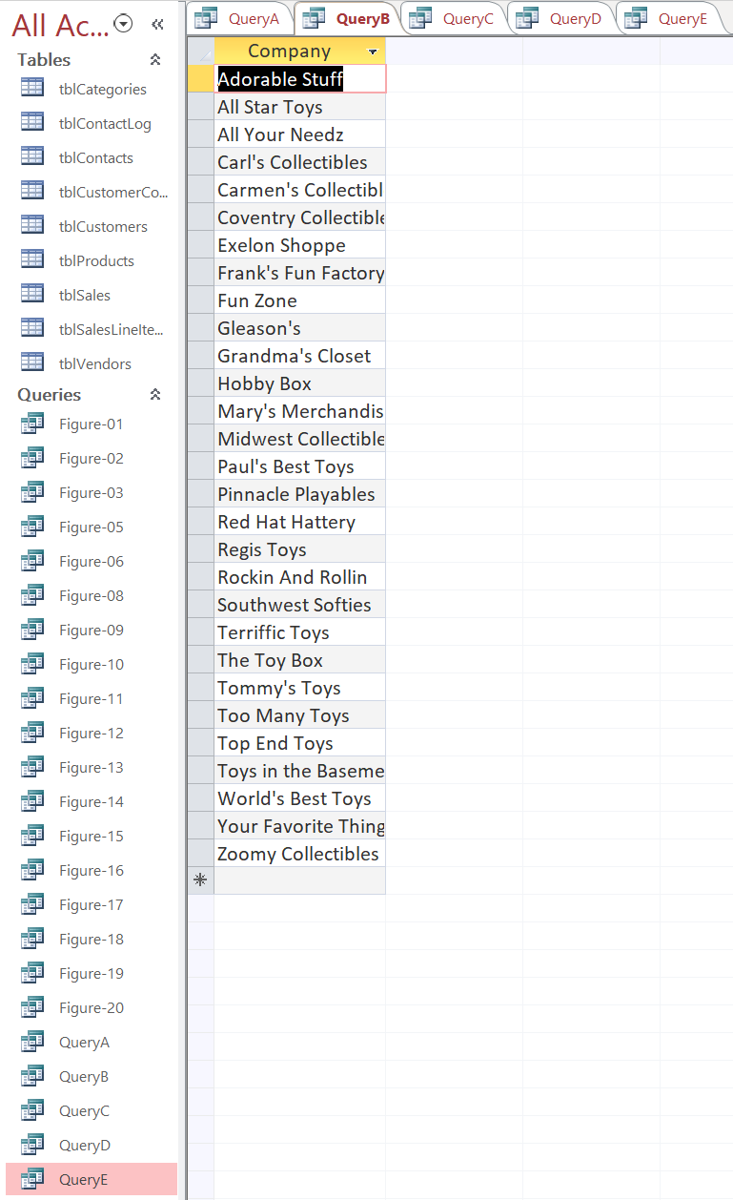

1. **Select the Description, Cost and QtyInStock fields from the Products table for all records with category “Trucks.” Sort by cost from lowest to highest cost.**

SELECT Description, QtyInStock, Cost

FROM tblProducts

WHERE Category='Trucks'

ORDER BY Cost;

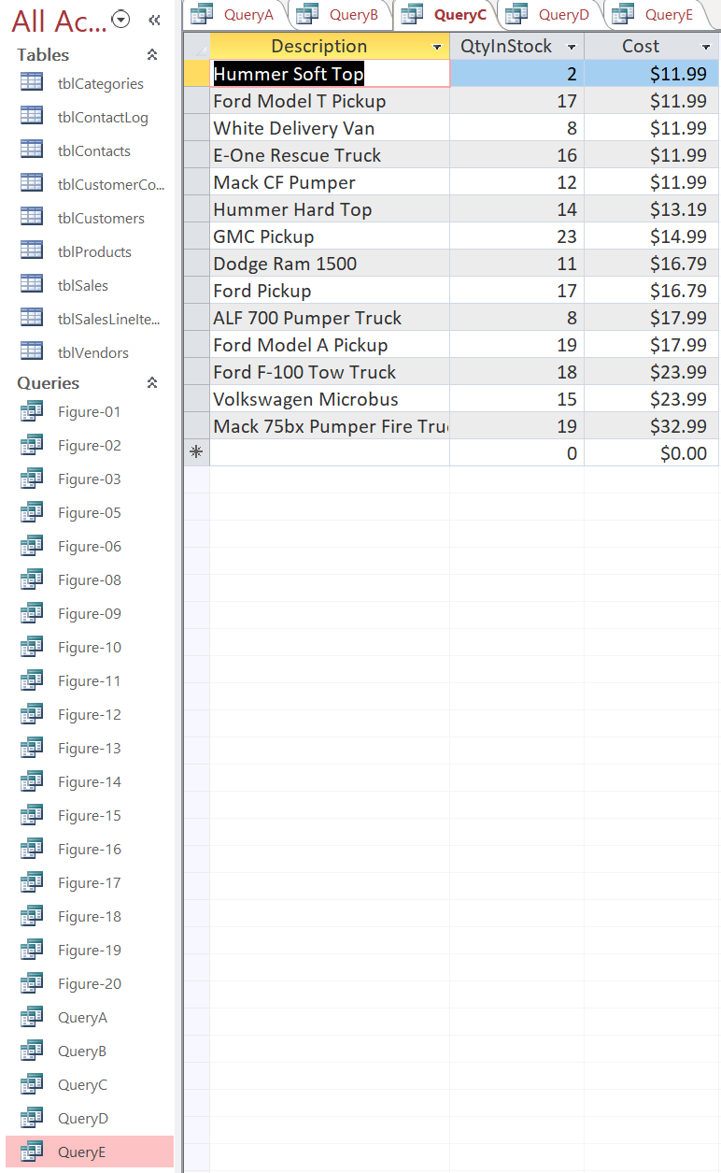

1. **Select the OrigCustDate, FirstName, and LastName from the Contacts table for all records with the state of Texas (“TX”) and OrigCustDate of January 1, 2013 or later. Display first and last name together as Customer Name.**

SELECT OrigCustDate, FirstName + LastName AS CustomerName

FROM tblContacts

WHERE State='TX' AND OrigCustDate >= #1/1/2013#;

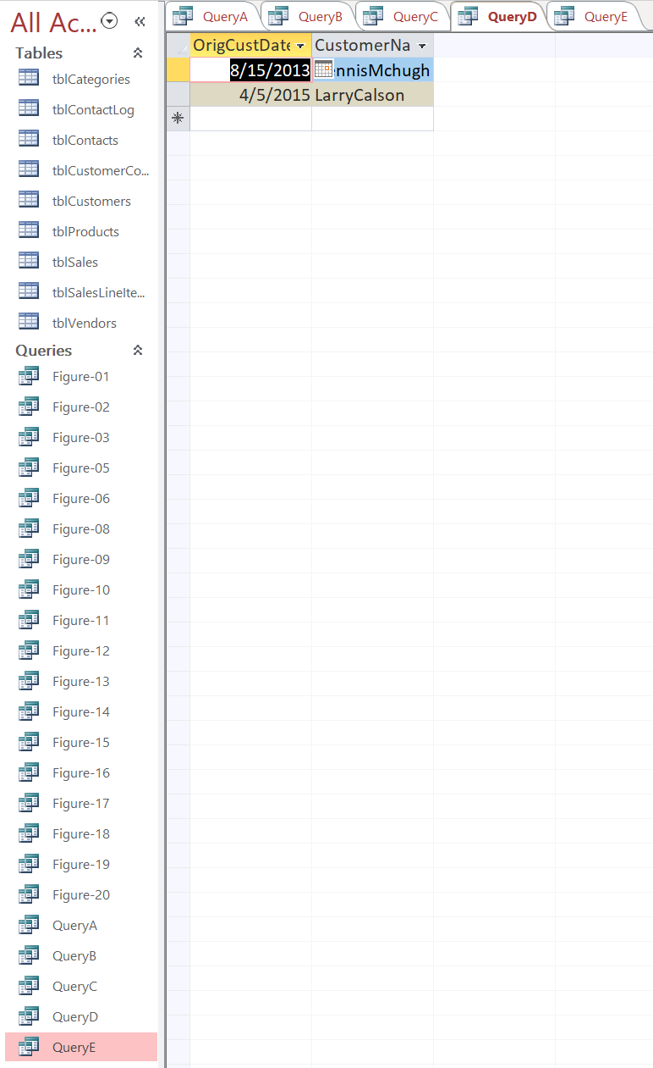

1. **Select the Company, CurrentBalance and State from the Customers table for all records with a current balance greater than to zero and a state of New York or Connecticut. Sort by CurrentBalance from highest to smallest value.**

SELECT Company, CurrentBalance, State

FROM tblCustomers

WHERE CurrentBalance >0 AND (State='NY' or State='CT')

ORDER BY CurrentBalance DESC;

